Ho, Ho, Ho, Merry Christmas!
It’s the time of the year where we are shopping for our families during this festive season. This math-based project will test your shopping savvy while practicing some important mathematical skills.

Your task is to select gifts for all members of your family coming as close to, without exceeding, $5000.00. You will search the internet and use newspaper flyers to find the gifts.

- Identify each member of your household by name and age. The age is important so that your gift is appropriate. Any person over 18 years of age should be identified by “adult”.
- Search the internet using a variety of websites and look through flyers to find a gift for each member. Be sure to print out a copy of your gift or cut out the picture from the flyer in order to prove your price. (1page)
- Make a table of your gifts. Include the name of the item, who it’s for, original price, coupon used, amount of discount, plus 13% sales tax.
- Round each price to the nearest penny.
- Create a pie graph using the recipients’ names and the total cost of each gift.
- Research the dimensions of the gift packaging for at least 3 items (not all gifts can be wrapped i.e. bike). Record measurements on separate page. Calculate the surface area of the gifts to determine how much wrapping paper you will require to make the gifts “tree ready”.

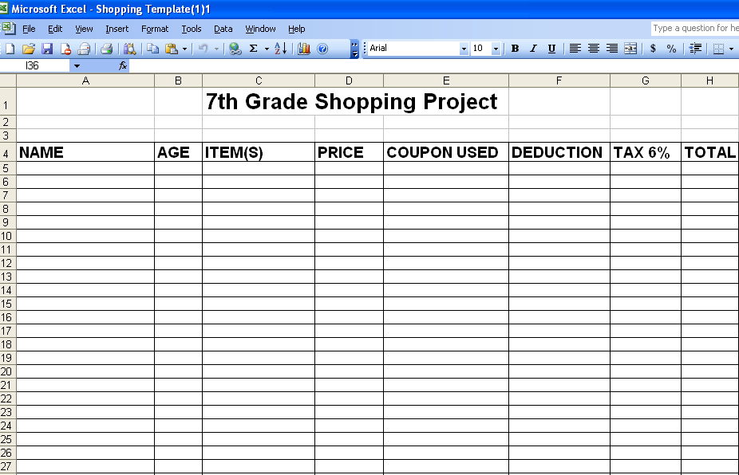
⬅ Table & Pie Chart & Gift Wrapping ⬇
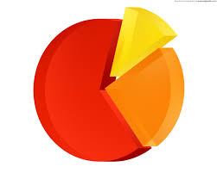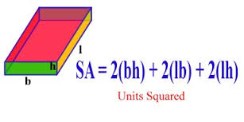

SALE!! Apply these discounts to your purchase
- Clothing 25% off
- Electronics 15% off
- Books, CDs, Videos 10% off
- Jewelry 20% off
- Everything Else 5% off

Savvy Shopper Math Based Project Rubric

Level 1 Level 2 Level 3 Level 4
Table | Used the table to provide information on the holiday shopping project. Some of the required information is missing | The table includes most of the required information | The table includes all of the required information. | The table includes all of practitioner plus accurate total calculations for each family member.
Budgeting | Shows little attempt to come up with a solution to planning a budget and total exceeds or comes within $1000 | Reveals an unsuccessful attempt to plan a budget and total comes within $500 | Features acceptable solutions to planning a budget and total comes within $250 | Effectively uses a budget to plan expenditures and total comes within $100
Calculation | Features significant mathematical errors in calculations on tax and savings in the use of coupons | Features some mathematical errors in calculations on tax and savings in the use of coupons | Correctly calculates the tax and savings in the use of coupons | Correctly calculates the tax and savings in the use of coupons and shows all work.
Graph | A pie graph missing some information. | A pie graph that includes legend but no data labels or title. | A pie graph that includes;  - title  - data labels  - legend | Includes all components and another type of graph.
Gift Wrap | Does not include measurements of 3 items Surface area or has significant errors in calculations. | Includes some measurements of items of Surface area or has minor errors in calculations | Includes all measurements to calculate Surface area of 3 gifts with no errors, | Includes all measurements of surface area and volume calculations

