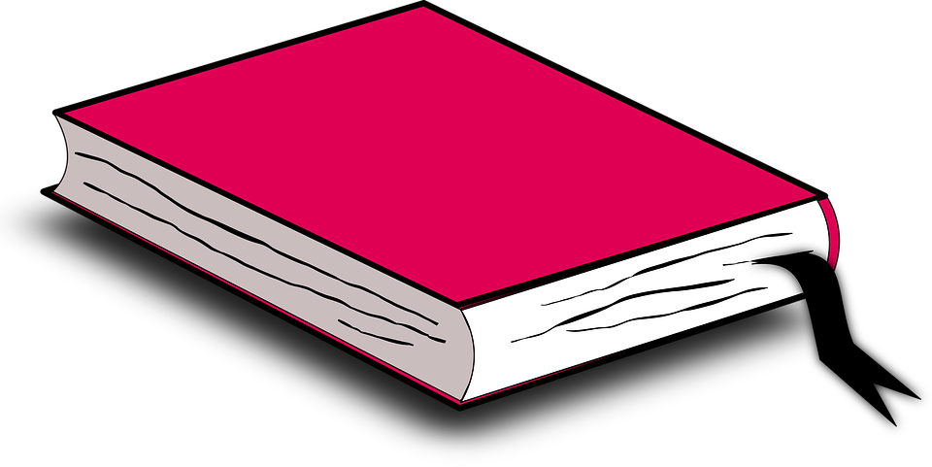
Independent Reading
This month you will have Six tasks to complete whilst reading your novel. The six options can be worked on and completed in any order and handed in as a package at the end of the month. The options range from artistic to linguistic tasks, so work hard to compete with your best effort.
OPTION ONE: Make up an acrostic poem that relates to something in your book. It could be the name of a character or it could be a re-occuring theme or idea. Please remember that you should be selecting a variety of good adjectives to describe the word you choose and include complete sentences.
OPTION TWO: Pretend you are a reporter for a well-known newspaper. Create a list of 6 to 8 interview questions for one of the characters in your book. Once you have the questions created, become the character and answer them. Be sure to include specific details. You may also want to use the 5Ws!
OPTION THREE: Select 10 examples of figurative language we have studied this term from your book. Be sure to state what figurative type it is and also include the text as it is written in the book with it. Some types you may select are below:
Metaphor Simile Personification Onomatopeia Alliteration Hyperbole
OPTION FOUR: Find 10 new or interesting words from your book. Using a dictionary or the Internet, find the meaning of the word and then use each word in a complete sentence.

OPTION FIVE: Visualize your novel. Using a blank 8 x 11 paper to illustrate a place, scene or person from your novel. On the back write and explain what the significance was and why you selected it.

OPTION SIX: Personal Choice. Create a task on your own that shows your interest, knowledge or creativity towards the novel. There are many ideas on google that highlight a novel. Explore and create!

Independent Reading Rubric
 | Level 1 | Level 2 | Level 3 | Level 4
Ideas/Content  Does your work reveal that you have thoroughly read the novel and you understand the elements within the novel? | demonstrates poor comprehension of text excluding details from the text and no examples of setting, events characters, and literary elements | demonstrates limited comprehension of text using details from the text missing examples of setting, events characters, and literary elements | demonstrates comprehension of text using details from the text and includes some examples of setting, events characters, and literary elements | demonstrates excellent comprehension of text using details from the text and includes examples of setting, events characters, and literary elements
Reading Strategies  Do you make clear connections between the novel? Do you specifically reference the novel, make, predictions, infer happenings and/or summarize the main details? | Demonstrates no thoughtful analysis. Lack of inferencing and connections to story.  Developing reading strategies. | Demonstrates a somewhat thoughtful analysis; some connections made. Limited inference to story elements.  Limited use of reading strategies. | Demonstrates some insight and thoughtfulness in analysis. Connections are evident. An effort to infer and relate to characters and situations is evident.  Good use of reading strategies | Demonstrates very insightful and thoughtful analysis; connections are very relevant and clearly communicated. A, strong ability to infer, relate to characters and situations. Strong use of reading strategies.
Sentence Structure/  Conventions  Does your written work communicate clearly and effectively? Is your writing detailed? Do you use appropriate grammar, spelling, and punctuation? | Organization is not clear. Sentences are repetitive and nonsensical. Lack of editing is distracting to reader. | Limited organization is evident. Sentences are repetitive and lack fluidity. Lack of consistent editing is distracting to the reader. | Some organization is evident. Sentences are well written and non repetitive. Only minor editing oversights | Organization is very clear. Sentences are thoughtful, non repetitive and of high quality. Spelling and conventions have been effectively edited.
Creativity  Do you use personal creativity?Do you add your own interest and flare to the assignment? Have you put in a lot of thought and care? | There is little evidence of creativity in the project. The creator does not demonstrate much imagination. | contains some creative details and/or descriptions, but they distract from the project. The creator has tried to use his imagination. | contains adequate creative details and/or descriptions that contribute to the viewers enjoyment. The creator has used his/her imagination. | contains many creative details and/or descriptions that contribute to the viewers enjoyment. The creator has really used his/her imagination.

